Practical no. 15
Name :- Danish Altaf Solkar Enrolment no. :-24111590805
Class :- CO3K – B Subject :- DMS
Aim:- Execute Queries for Ordering and Grouping data

QUERY :- CREATE TABLE EMPL(EMPNO NUMBER(5) PRIMARY KEY, EMPNAME VARCHAR(10) NOT NULL, SALARY NUMBER(6), DEPT VARCHAR(12), ADDRESS VARCHAR(10));

QUERY :- INSERT into EMPL values(1,'Danish',25000,'Admin','Neral');
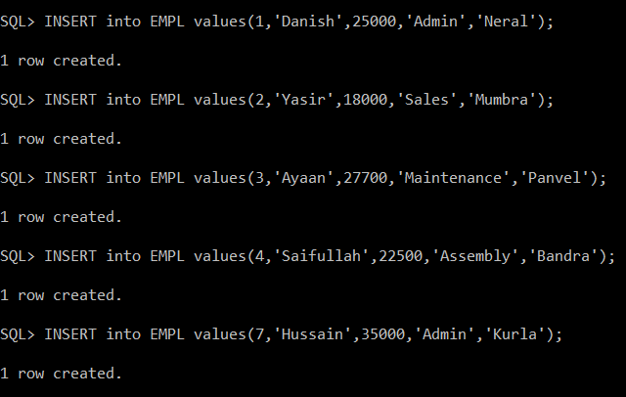

QUERY :- SELECT * FROM EMPL;
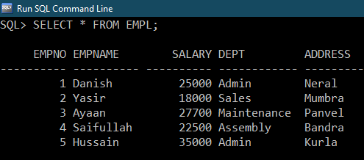

QUERY :- SELECT * FROM EMPL WHERE empno = 1;
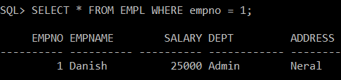

QUERY :- SELECT * FROM EMPL WHERE salary>20000;
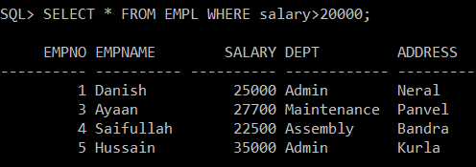

QUERY :- SELECT * FROM EMPL WHERE address='Panvel';
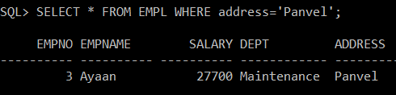

QUERY :- SELECT * FROM EMPL WHERE dept='Admin';
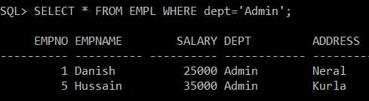

QUERY :- SELECT * FROM EMPL ORDER BY EMPNAME;
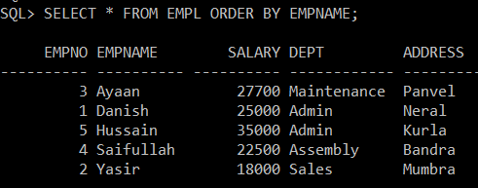

QUERY :- SELECT * FROM EMPL ORDER BY SALARY;
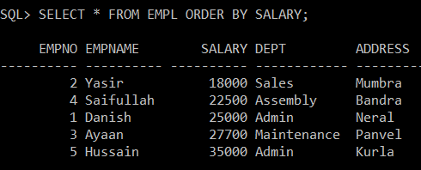

QUERY :- SELECT COUNT(dept),dept FROM EMPL GROUP BY dept;
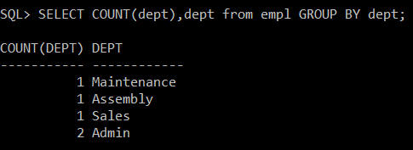

QUERY :- SELECT MAX(salary),dept FROM EMPL GROUP BY dept;
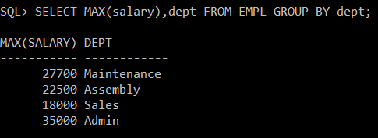

QUERY :- SELECT MIN(salary),dept FROM EMPL GROUP BY dept;
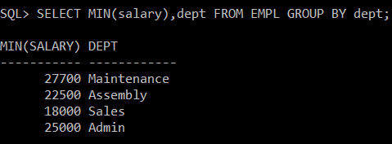

QUERY :- SELECT SUM(salary),dept FROM EMPL GROUP BY dept;
